**Module (JQuery Basic, Effects & Advanced) – 5**

1. **What is jQuery?**

Ans:- jQuery is a fast, small, and feature-rich JavaScript library. It simplifies things like HTML document traversal and manipulation, event handling, and animation, providing an easy-to-use API that works across a multitude of browsers. jQuery is designed to make front-end web development more straightforward and efficient.

Key features and aspects of jQuery include:

1. DOM Manipulation: jQuery simplifies HTML document traversal and manipulation. You can easily select and modify elements on a page using jQuery's selectors and methods.

2. Event Handling: jQuery provides a concise and consistent way to handle events, such as user clicks, keypresses, and form submissions. This helps in writing cross-browser compatible event-handling code.

3. Ajax: jQuery simplifies the process of making asynchronous HTTP requests (Ajax calls). It provides methods like `$.ajax()` to fetch data from a server without requiring a page reload.

4. Animations: jQuery includes built-in functions for creating animations and effects, making it easier to add visual enhancements to a web page.

5. Cross-browser Compatibility: jQuery handles many of the differences between browsers, providing a more consistent and reliable experience for developers.

6. Plugins: jQuery has a large ecosystem of plugins that can be easily integrated to extend its functionality. These plugins cover a wide range of tasks, from sliders and carousels to form validation and more.

7. Chaining: jQuery allows method chaining, which means you can perform multiple operations on the same set of elements in a single line of code. This results in more concise and readable code.

Here's a simple example of jQuery code to hide an element when a button is clicked:

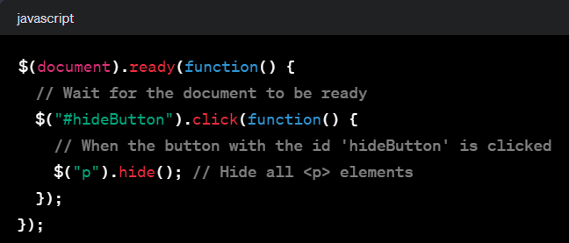

1. **How to Apply CSS Using JQuery, How to Add Class and Remove Class in Jquery , JQuery Animation?**

**Ans:**

**Applying CSS Using jQuery:**

**You can use the .css() method in jQuery to apply CSS styles to elements. Here's an example:**

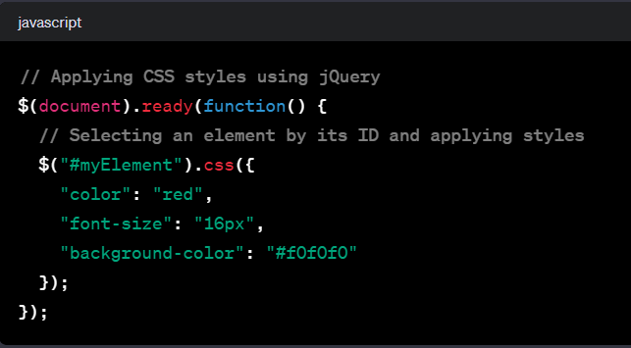

**In this example, the css() method is used to apply various styles to an element with the ID "myElement".**

**Adding and Removing Classes in jQuery:**

**You can use the addClass() and .removeClass() methods to add and remove classes from elements. Here's an example:**

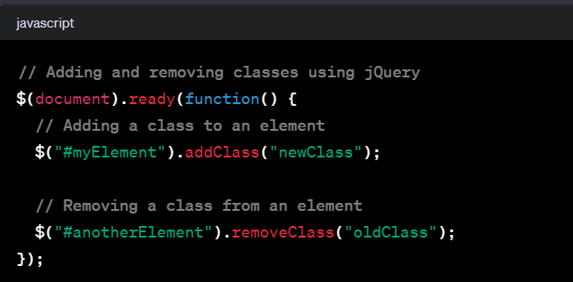

**In this example, the addClass() method adds the class "newClass" to the element with the ID "myElement", and the removeClass() method removes the class "oldClass" from the element with the ID "anotherElement".**

**jQuery Animation:**

**jQuery provides several methods for creating animations, such as**

**.hide() .show()**

**.fadeIn() .fadeOut()**

**.slideUp() .slideDown()**

**You can also use the `.animate()` method for more customized animations.**

**Here's an example of using the `.animate()` method to create a simple animation:**

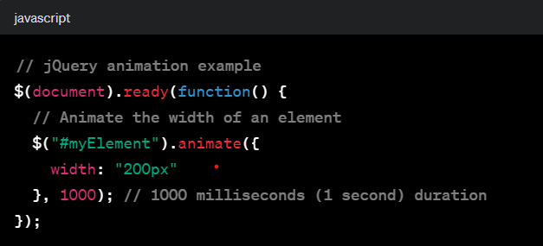

**In this example, the `animate()` method is used to gradually change the width of the element with the ID "myElement" to 200 pixels over a duration of 1000 milliseconds.**

1. **How to create slider with animation?**

**Ans:- Here are some common sliding methods in jQuery:**

1. slideUp():
2. slideDown():
3. slideToggle():
4. animate():

you can use the slideDown(), slideUp(), and slideToggle() methods along with the animate() method. Here's an example demonstrating sliding animations with jQuery:

CODE FILE ATTACHED IN GITHUB! PLEASE FIND IT

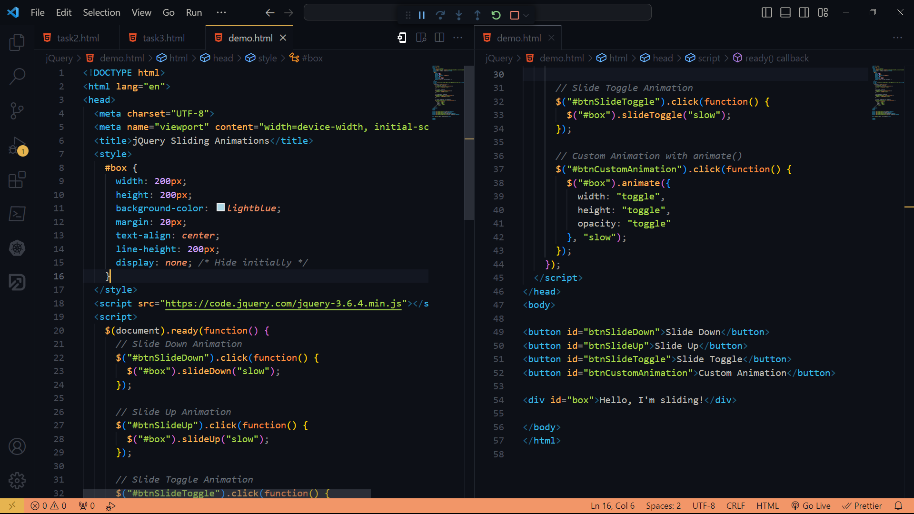

**OUTPUT**

